Without using principles of good screen design

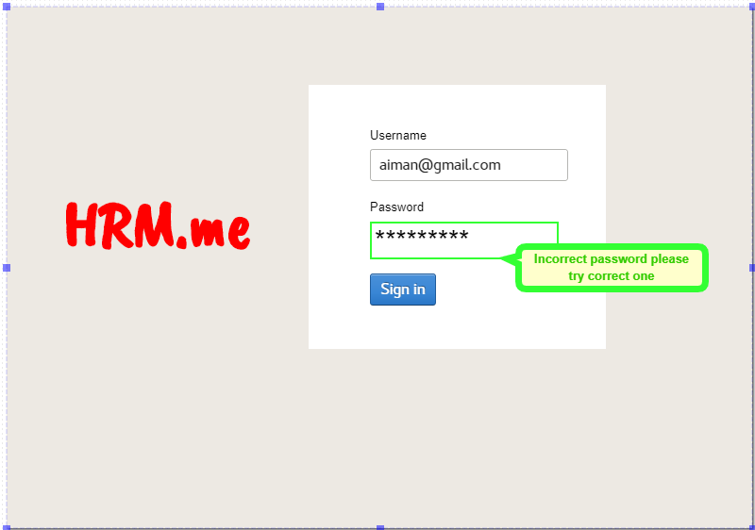

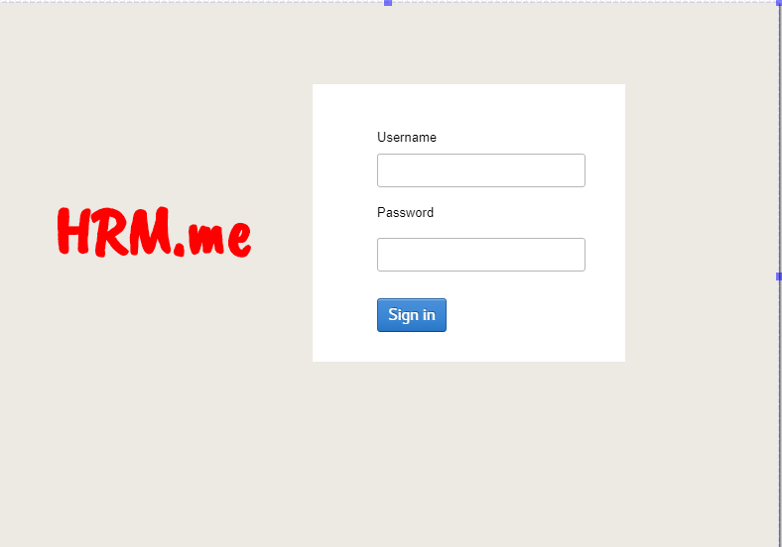

With using principles of good screen design

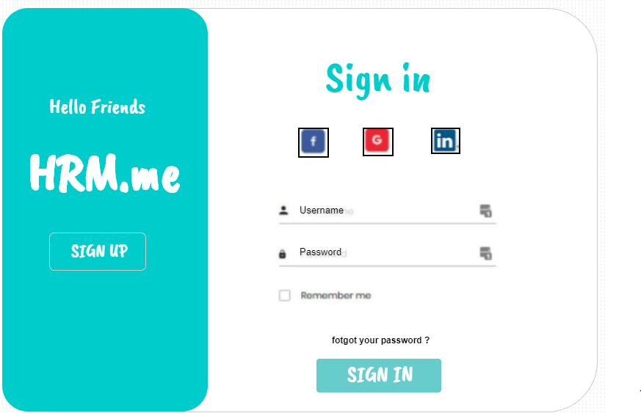

* Are appropriate screen elements are used in your project?

Yes, of course appropriate screen elements are used in second screen with design and screen principle color, texture ,text, label etc.

Appropriate elements used in making screen like

* List all the components used and their relevance.

1. Good text (visible)
2. Proper labeling
3. Password field hide and show
4. Username field
5. Sign in button
6. Forgot password link
7. Remember me radio box (check box)
8. Sign up button
9. System name
10. Logo of Facebook, linked in and google
11. Username and password pic of person and lock for password

* Explain how your screen design is able to achieve following goals.
* Reduce visual work

Yes it reduces the visual work people easily can see each and everything like sign in and sign up page, how they can use forgot password link and remember me radio button (check box) they can even sign up with Facebook, linked in, google.

* Reduce intellectual work

Using this type of thing people can easily interact with system and easy to use. How to use each functionality people easily understand

* Reduce memory work

Reduce short-term memory load. Therefore, interfaces should be as simple as possible with proper information hierarchy, and choosing recognition over recall.

* Increase predictability

People easily understand sign in and sign up steps with different features like directly login and signup with google, Facebook etc. accounts